Lecture 2.3.1
Subgroups

Course outcome to be covered:
CO1: Apply and recognized about the Subgroups

Group
A monoid with inverse element is known as a group. The inverse element I, is the element of the set S such that (aοI)=(Iοa)=a, for each of the element a∈S. It can be said that four properties can be hold by the group – Closure, Associative, Identity and Inverse. The number of elements in the group G is represented by the order of the group G.
Examples
Under the operation of matrix multiplication, the set of N×N non-singular matrices form a group.
Closure property holds true as the product of two N×N non-singular matrices is also an N×N non-singular matrix, thus holding true the associative property.
The set of N×N non-singular matrices contains the identity matrix holding the identity element property.
As all the matrices are non-singular they all have inverse elements which are also nonsingular matrices. Hence, inverse property also holds.

Abelian Group
A group for which the element pair (a,b)∈G always holds commutative is known as abelian group G, thus holding true five properties – Closure, associative, identity, inverse and commutative.
Example
The set of positive integers (including zero) with addition operation is an abelian group. G={0,1,2,3,…}
Here closure property holds as for every pair (a,b)∈S,(a+b) is present in the set S.
For example, 1+2=2∈S and so on
Associative property also holds for every element a,b,c∈S,(a+b)+c=a+(b+c)
For example, (1+2)+3=1+(2+3)=6
Identity property also holds for every element a∈S,(a×e)=a
For example, (2×1)=2,(3×1)=3. Here, identity element is 1.
Commutative property also holds for every element a∈S,(a×b)=(b×a)
For example, (2×3)=(3×2)=3

Cyclic Group and Subgroup
A group that is generated by using a single element is known as cyclic group. Cyclic group is considered as the power for some of the specific element of the group which is known as a generator. The generator ‘g’ helps in generating a cyclic group such that the other element of the group is written as power of the generator ‘g’.
Example
The set of complex numbers {1,−1,i,−i} under multiplication operation is a cyclic group.
There are two generators − i and –i as i1=i,i2=−1,i3=−i,i4=1 and also (–i)1=−i,(–i)2=−1,(–i)3=i,(–i)4=1 such that it covers all the elements of the group thus forming a cyclic group.
Note – Every cyclic group is an abelian group but not every abelian group is a cyclic group.
If the four properties (Closure, associative, identity and Inverse) are simultaneously satisfied by the subgroup H then it will be a subset of the group G, represented as H≤G.
A subgroup H of a group G that does not include the whole group G is called a proper subgroup (Denoted by H<G). A subgroup of a cyclic group is cyclic and a abelian subgroup is also abelian.
Example
Let a group G={1,i,−1,−i}
Then some subgroups are H1={1},H2={1,−1}
This is not a subgroup − H3={1,i} because that (i)−1=−i is not in H3
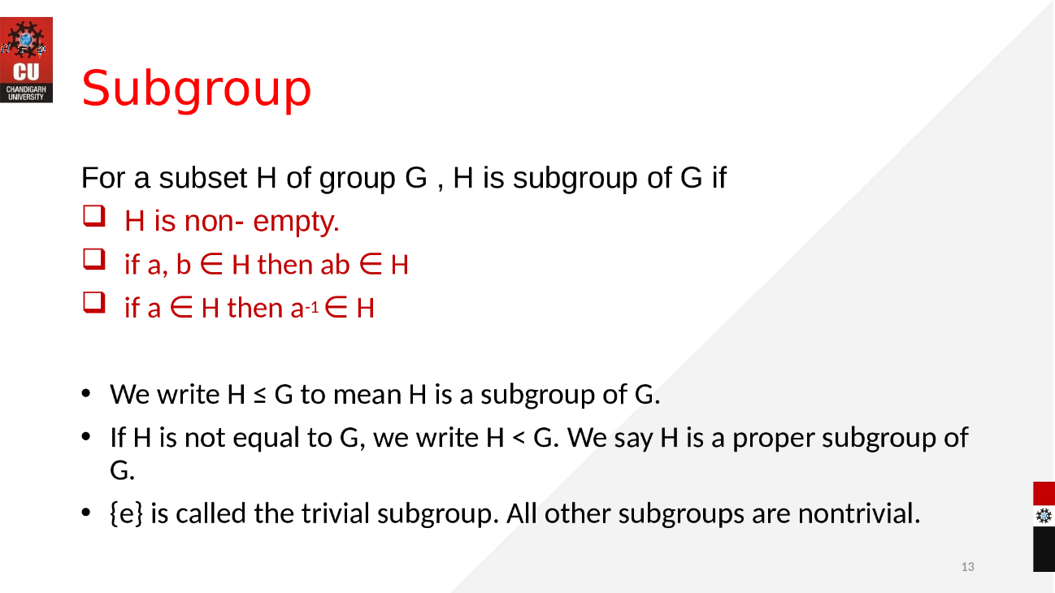

eBook Discrete Mathematics :
https://sites.millersville.edu/bikenaga/abstract-algebra-1/subgroups/subgroups.pdf
Video link:
- https://www.youtube.com/watch?v=TJAQNlGvfjE&list=PLi01XoE8jYoi3SgnnGorR_XOW3IcK-TP6&index=5
- https://www.youtube.com/watch?v=8A84sA1YuPw&list=PLi01XoE8jYoi3SgnnGorR_XOW3IcK-TP6&index=9

